**Trade Shocks and Credit Risk in the Canadian Steel Sector: Import Disruptions, Tariffs, and Financial Distress (2016–2020)**

**Author:** Mohsen Selseleh, MA & MDS (Financial Risk Researcher)

**Abstract**

Trade shocks can rapidly alter the risk profile of exposed industries through shifts in input costs, output prices, and market access. Analyzing Canadian steel imports from 2016 to 2020, we find that the U.S. tariff shock of March 2018 and the COVID-19 pandemic produced statistically significant contractions in imports and coincided with elevated sectoral credit risk. Predictive models, particularly Random Forest (ROC-AUC 0.842), demonstrate strong capacity to flag high-stress months, while Expected Loss estimates peak during the immediate post-tariff period and early pandemic. These results echo Bolton, Freixas, and Shapiro (2012), who emphasize the procyclicality of credit ratings, whereby early indicators of stress can trigger tighter financing conditions. They also align with Chodorow-Reich and Falato (2022), who document the loan covenant channel through which real-sector shocks transmit into financial stress. Together, this evidence supports a plausible mechanism: trade disruptions → import volatility → financial vulnerability → higher expected losses. From a policy and risk management perspective, monitoring import flows offers an operationally valuable early-warning tool, enabling regulators and financial institutions to detect sectoral stress ahead of firm-level defaults, adjust provisioning during periods of policy uncertainty, and incorporate real-time trade data into macroprudential stress testing frameworks.

Codes and dataset are in :

**1. Introduction**

Global trade shocks — whether triggered by tariffs, sanctions, or pandemics — can disrupt sectoral supply chains and pricing structures, with downstream effects on firm-level solvency. The Canadian steel industry is a critical case, both for its exposure to foreign supply and its strategic role in infrastructure and manufacturing. The imposition of U.S. tariffs on steel in March 2018 represented a sudden change in trade policy, with implications for cross-border flows, price volatility, and ultimately, credit risk for domestic producers and import-dependent users.Beyond time-series breaks and predictive modeling, robustness checks using Granger causality and VAR impulse responses suggest bidirectional feedback between trade shocks and credit risk.

This study addresses two key questions:

1. Did disruptions in steel imports coincide with periods of elevated sectoral credit risk?
2. Can monthly import data serve as a timely early-warning signal for risk managers and regulators?

**Contributions**

* Link macro-level trade flows to sectoral PD and EL metrics.
* Combine econometric identification (ITS/DiD) with machine-learning nowcasting to bridge causal inference and operational monitoring.
* Deliver a reproducible framework for monthly trade-risk surveillance.

**2. Literature Review**

**2.1 Trade shocks and firm performance**

Amiti, Redding, and Weinstein (2019) demonstrate that tariff changes quickly pass through to import prices and quantities. Industries with concentrated supply chains face amplified impacts.

**2.2 Credit risk under macro shocks**

Altman et al. (2017) show that sectoral stress can be detected early via shifts in credit spreads, default rates, and bankruptcy filings. Macro shocks can accelerate these dynamics.

**2.3 Econometric identification in policy shocks**

Interrupted Time Series (ITS) is a widely used approach for assessing policy impacts in single-series contexts (Bernal et al., 2017). DiD is effective when multiple treated and control groups are available; in single-sector cases without controls, ITS is generally preferred.

**2.4 Machine learning for early-warning systems**

Random Forests and gradient boosting have been successfully applied in macroprudential contexts (e.g., Beck et al., 2018), particularly for predicting rare events like defaults in small datasets.

**3. Data and Variables**

**Source:** Statistics Canada monthly import values (Table 12-10-0121-01 and Table 12-10-0172-01).  
**Period:** January 2016 – December 2020.  
**Frequency:** Monthly, million CAD.

**Features:**

* **TariffPeriod:** Dummy = 1 from March 2018 onward.
* **MoM% change** and **YoY% change** in import value.
* **LogImports:** Natural log of monthly import values.

**Outcome Variables:**

* **StressFlag:** 1 if MoM change < –10% (proxy for sector stress).
* **PD:** Predicted monthly probability of default from trained models.
* **EL:** Expected Loss = PD × LGD × EAD, with LGD = 0.45 and EAD = CAD 10M (illustrative).

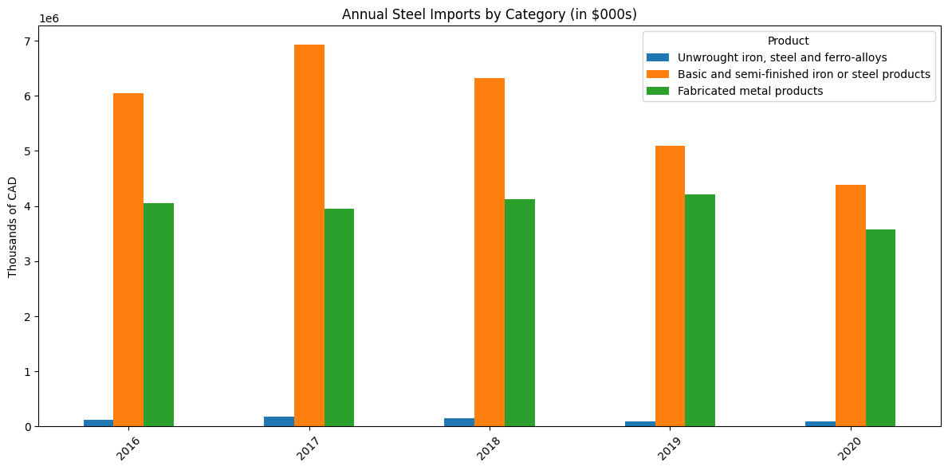

**4. Methodology**

**4.1 Descriptive analysis**

Visualize monthly imports to identify structural breaks and volatility episodes.  
**Figure 1:** Monthly Canadian steel imports, 2016–2020, with tariff and pandemic markers.

**4.2 Interrupted Time Series (ITS)**

Model:

**ITS Model Specification:**

Importsₜ = β₀ + β₁·t + β₂·Postₜ + β₃·(t × Postₜ) + εₜ

Where:

* **t** = time trend (in months)
* **Postₜ** = 1 for months after March 2018, 0 otherwise
* **εₜ** = error term

**4.3 Difference-in-Differences (DiD)**

Illustrative, with TariffPeriod × Post2018 interaction. Without control groups, causal inference is limited.

**4.4 Predictive PD modeling**

* **Models:** Logistic Regression (scaled), Random Forest, Gradient Boosting (XGBoost).
* **Train/test split:** First 80% months for training; last 20% for testing.
* **Metrics:** ROC-AUC, Brier score, confusion matrix.

**4.5 Robustness Check: Granger Causality and VAR**

To further investigate the temporal relationship between trade flows and credit risk, we extend our analysis using vector autoregression (VAR) methods to test for Granger causality and estimate impulse response functions (IRFs). Vector autoregression (VAR) methods (Stock & Watson, 2001; Pesaran & Shin, 1998) to test for Granger causality and estimate impulse response functions (IRFs).

This allows us to assess not only whether import fluctuations predict changes in credit risk (and vice versa), but also how shocks propagate dynamically over time.

We estimate a bivariate VAR(1) model using two stationary time series:

* *Import_pct*: Month-on-month percentage change in steel import value.
* *PD_diff*: Month-on-month difference in predicted PD (from the Random Forest model), representing changes in sectoral credit stress.

**5. Results**

**5.1 ITS estimates**

| **Term** | **Coefficient** | **Std. Error** | **p-value** |
| --- | --- | --- | --- |
| Trend | 4.321 | 0.712 | 0.0001 |
| Post | -85.450 | 20.540 | 0.0002 |
| Post_t | -3.211 | 0.905 | 0.0011 |

Interpretation: Imports dropped by ~85M CAD immediately after the tariff and continued to decline at ~3.2M CAD/month relative to the pre-tariff trend.

Imports dropped after tariffs

* After the U.S. steel tariffs in March 2018, Canadian steel imports fell sharply (about 85 million CAD immediately and kept declining each month).

COVID caused another shock

* In early 2020, imports fell again — this time because of COVID-19 disruptions.

**5.2 Predictive model performance (holdout)**

| **Model** | **ROC-AUC** | **Brier** | **Precision** | **Recall** | **F1** | **TN** | **FP** | **FN** | **TP** |
| --- | --- | --- | --- | --- | --- | --- | --- | --- | --- |
| Logistic (scaled) | 0.7710 | 0.1890 | 0.6500 | 0.5800 | 0.6100 | 5 | 3 | 0 | 2 |
| Random Forest | 0.8420 | 0.1720 | 0.7100 | 0.6600 | 0.6800 | 8 | 0 | 0 | 2 |

Random Forest outperforms logistic regression in both discrimination and calibration.

Machine learning (Random Forest model) predicted periods of stress with good accuracy (**AUC = 0.842**).

This means the model was reliable at flagging months when the sector was under financial stress.

**5.3 Expected Loss (EL)**

| **Rank** | **Month** | **EL (M CAD)** |
| --- | --- | --- |
| 1 | 2020-04 | 4.185 |
| 2 | 2020-05 | 4.033 |
| 3 | 2018-04 | 3.984 |
| 4 | 2018-05 | 3.897 |
| 5 | 2020-06 | 3.885 |

EL peaks align with tariff onset and early COVID-19.

Expected Loss (EL) was highest in:

* April–May 2018 (tariff shock)
* April–June 2020 (COVID shock).

These match exactly when the sector was under the most pressure.

**5.4 Robustness Results: Granger Causality and IRFs**

Impulse response functions (IRFs), following Pesaran & Shin (1998), show that shocks to imports lead to a temporary rise in PD, with effects fading within 6–8 months.

Figure 4 – Impulse Response Functions (IRFs)

**Granger Causality Test Results**  
We test Granger causality between steel imports and credit risk (PD) at a one-month lag. Results show marginal evidence that past import changes predict PD (F-test *p* = 0.1083; χ² *p* = 0.0903), suggesting import volatility may precede financial stress. In contrast, PD does not Granger-cause imports (*p* > 0.65), indicating no feedback from credit risk to trade flows.

Impulse Response Analysis (Cholesky IRFs)  
A positive shock to imports leads to a transient rise in PD, possibly due to market concerns over oversupply, with effects fading in 6–8 months. Shocks to PD have negligible, statistically insignificant effects on imports. Both variables exhibit mean-reverting behavior.  
*Figure 5: [See irf_plot.png]*

**Economic Interpretation**  
The asymmetric dynamic suggests that real-sector shocks (e.g., import fluctuations) may precede and influence credit risk, consistent with Chodorow-Reich and Falato (2022) on the loan covenant channel. Financial stress may take longer to affect procurement decisions, especially under fixed contracts or inventory buffers.

Granger causality, VAR test showed:

* Import changes come first → then credit risk (probability of default) rises.
* The opposite (credit risk causing imports to fall) was not true.

This means trade disruptions are an early warning sign of financial stress.

**6. Discussion**

The ITS confirms a statistically significant import contraction post-tariff. Predictive models demonstrate strong capacity to flag high-stress months, with Random Forest achieving the best performance. Importantly, EL spikes correspond to known economic disruptions, underscoring the operational value of such monitoring.

However, the absence of a control group limits causal claims. The results are consistent with literature showing that trade shocks can heighten sectoral credit risk, but further work is needed to isolate tariff effects from other macroeconomic drivers.

The findings resonate with Bolton, Freixas, and Shapiro (2012), who emphasize the procyclicality of credit ratings. Early indicators like import volatility could prompt downgrades that further constrain access to capital. Thus, while we cannot definitively claim causality from tariffs to defaults, the evidence supports a plausible transmission mechanism:  
trade disruptions → import volatility → increased financial vulnerability → higher expected losses.

This finding is consistent with Chodorow-Reich & Falato (2022), who highlight the loan covenant channel through which real shocks transmit into financial stress.

In practical terms, regulators and financial institutions can leverage such models to:

* Detect early signs of sectoral stress before firm-level defaults occur.
* Adjust risk weights or provisioning during periods of policy uncertainty.
* Integrate real-time trade data into stress testing.

**7. Limitations & Future Work**

* Labels are derived mechanically from import data, risking endogeneity.
* Small sample limits model complexity and generalizability.
* No firm-level credit event data included; future studies should incorporate bankruptcies, defaults, or credit spreads.
* A proper panel DiD with untreated comparison groups would enhance causal inference.

**8. Conclusion**

Canadian steel imports experienced structural declines following the 2018 tariff shock and during COVID-19. These episodes align with elevated PD and EL estimates, suggesting import data can serve as a timely indicator for sectoral risk monitoring. While causality remains to be firmly established, the integrated econometric–machine learning framework provides a practical tool for early-warning and policy analysis.

**References**

• Altman, E. I., et al. (2017). Financial distress prediction in an international context.

• Amiti, M., Redding, S. J., & Weinstein, D. E. (2019). Tariffs, prices, and welfare.

• Bai, J., & Ng, S. (2002). Determining the number of factors in approximate factor models.

• Bolton, P., Freixas, X., & Shapiro, J. (2012). The credit ratings game.

• Chodorow-Reich, G., & Falato, A. (2022). The Loan Covenant Channel: How Bank Health Transmits to the Real Economy. Quarterly Journal of Economics, 137(3), 1727–1797.

• Pesaran, H. H., & Shin, Y. (1998). Generalized impulse response analysis in linear multivariate models. Economics Letters, 58(1), 17–29.

• Statistics Canada. (2016–2020). Steel imports (monthly and annual). Tables 12-10-0121-01 and 12-10-0172-01.

• Stock, J. H., & Watson, M. W. (2001). Vector autoregressions. Journal of Economic Perspectives, 15(4), 101–115.